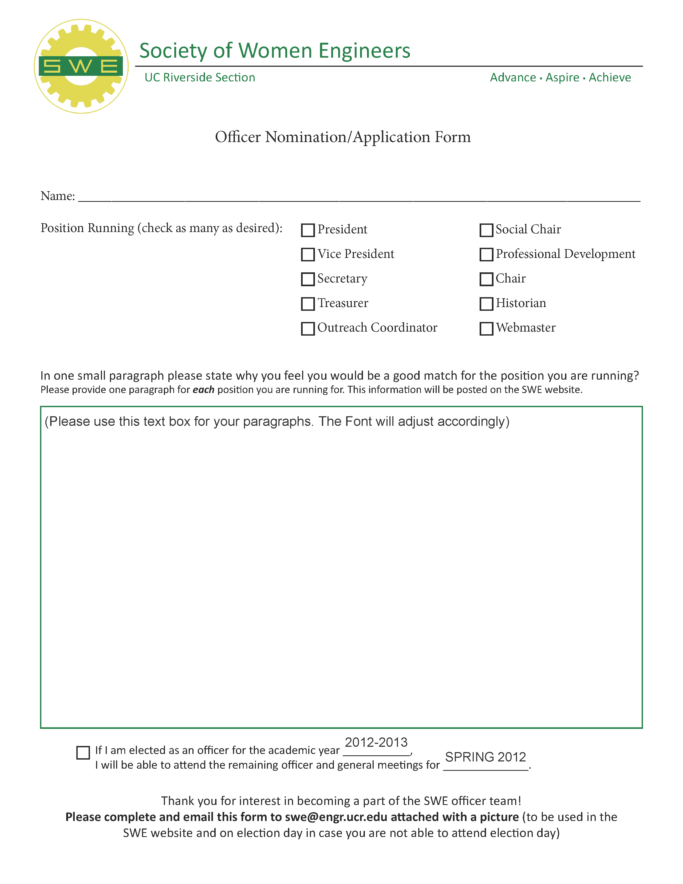
Tasnia Qazi
President
SWE@UCR has taught me essential skills that are needed to work with others and reach out to the community. As a current officer of SWE, it is within my obligations to assist the other officers with their respective duties. Some of the aspects I have been involved with include being a member of the SSED Planning Committee for outreach; attending the ASUCR budget meetings for the treasury; supporting and being a part of the sports teams for social; and participating in conferences for professional. I believe that the exposure I have received through my commitment to SWE will enable me to coordinate and help the future officers with their positions, as well as personally give back to the student organization that has given so much to me.
Vice President

Spring 2013
2013-2014

